Simple Attribute

🌟 Definition
# Source: AI Source: Provided by: [Data Path: Persons Table -> ID Column: 1, Name_En Column: Motasem Essam] -> From: [ChatGPT] on [6/10/2026]
A Simple Attribute (also called an Atomic Attribute) is an attribute that cannot be divided into smaller meaningful parts.
It stores a single value and is treated as one unit of data.

🎯 Purpose
# Source: AI Source: Provided by: [Data Path: Persons Table -> ID Column: 1, Name_En Column: Motasem Essam] -> From: [ChatGPT] on [6/10/2026]
Simple attributes are used to store:
- Individual pieces of information
- Single values
- Data that does not need further breakdown

🧠 Simple Examples
# Source: AI Source: Provided by: [Data Path: Persons Table -> ID Column: 1, Name_En Column: Motasem Essam] -> From: [ChatGPT] on [6/10/2026]
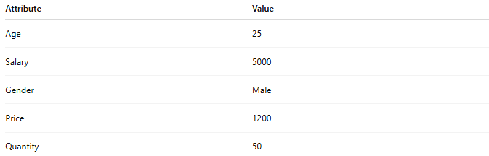
Attribute | Value
Age | 25
Salary | 5000
Gender | Male
Price | 1200
Quantity | 50
These attributes contain a single value and cannot be meaningfully split into smaller components.

📚 Customer Example
# Source: AI Source: Provided by: [Data Path: Persons Table -> ID Column: 1, Name_En Column: Motasem Essam] -> From: [ChatGPT] on [6/10/2026]
Entity
Customer
Attributes
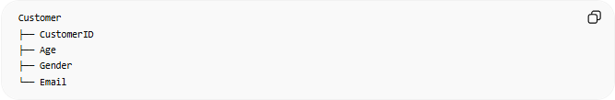
Customer
├── CustomerID
├── Age
├── Gender
└── Email
Simple Attributes:
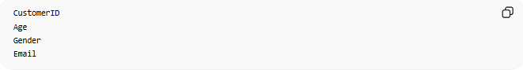
CustomerID
Age
Gender
Email

🗄️ Database Example
# Source: AI Source: Provided by: [Data Path: Persons Table -> ID Column: 1, Name_En Column: Motasem Essam] -> From: [ChatGPT] on [6/10/2026]
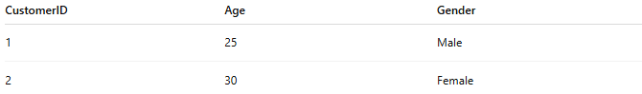
CustomerID | Age | Gender
1 | 25 | Male
2 | 30 | Female
Each column stores one atomic value.

🔢 Characteristics of a Simple Attribute
# Source: AI Source: Provided by: [Data Path: Persons Table -> ID Column: 1, Name_En Column: Motasem Essam] -> From: [ChatGPT] on [6/10/2026]
A simple attribute:
- Stores one value
- Cannot be subdivided
- Has one meaning
- Maps directly to a database column

📊 ER Diagram Representation
# Source: AI Source: Provided by: [Data Path: Persons Table -> ID Column: 1, Name_En Column: Motasem Essam] -> From: [ChatGPT] on [6/10/2026]
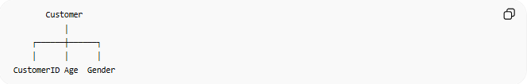
Customer
│
┌──────┼──────┐
│ │ │
CustomerID Age Gender
Each connected item is a simple attribute.

🌍 Real-World Examples

Student Entity
# Source: AI Source: Provided by: [Data Path: Persons Table -> ID Column: 1, Name_En Column: Motasem Essam] -> From: [ChatGPT] on [6/10/2026]
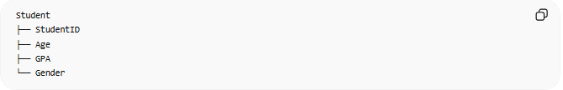
Student
├── StudentID
├── Age
├── GPA
└── Gender
Simple Attributes:
- StudentID
- Age
- GPA
- Gender

Product Entity
# Source: AI Source: Provided by: [Data Path: Persons Table -> ID Column: 1, Name_En Column: Motasem Essam] -> From: [ChatGPT] on [6/10/2026]
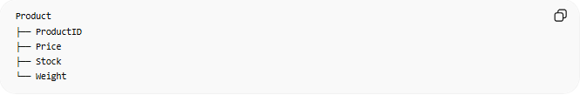
Product
├── ProductID
├── Price
├── Stock
└── Weight
Simple Attributes:
- ProductID
- Price
- Stock
- Weight

⚠️ Simple Attribute vs Composite Attribute
# Source: AI Source: Provided by: [Data Path: Persons Table -> ID Column: 1, Name_En Column: Motasem Essam] -> From: [ChatGPT] on [6/10/2026]
Simple Attribute
Age
Cannot be divided further.

Composite Attribute
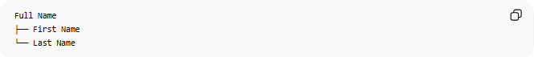
Full Name
├── First Name
└── Last Name
Can be divided into meaningful parts.

Comparison
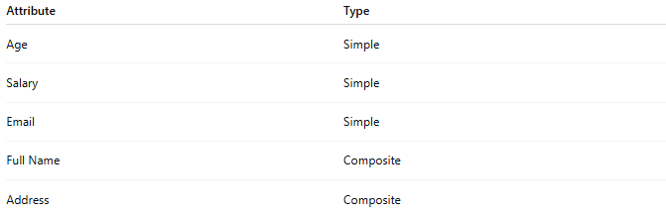
Attribute | Type
Age | Simple
Salary | Simple
Email | Simple
Full Name | Composite
Address | Composite

🧠 Simple Analogy
# Source: AI Source: Provided by: [Data Path: Persons Table -> ID Column: 1, Name_En Column: Motasem Essam] -> From: [ChatGPT] on [6/10/2026]
Think of a form field:
Age: 25
You cannot break "Age" into smaller meaningful pieces.
Therefore, Age is a Simple Attribute.
But:
Full Name: Ali Hassan
can be broken into:
First Name: Ali
Last Name: Hassan
so it is not a Simple Attribute.

🧭 Summary
# Source: AI Source: Provided by: [Data Path: Persons Table -> ID Column: 1, Name_En Column: Motasem Essam] -> From: [ChatGPT] on [6/10/2026]
A Simple Attribute is an attribute that stores a single, indivisible value and cannot be meaningfully split into smaller parts. Examples include Age, Salary, Price, and Gender. It is the most basic type of attribute in a data model.

